Earthmine QGIS Viewer – User Guide

# Installation and setup of plugin

Steps required:

1. Install flash player
2. Install plugin from plugin repository
3. Run plugin in QGIS

Install flash player

Install Flashplayer from <http://get.adobe.com/flashplayer/otherversions/>

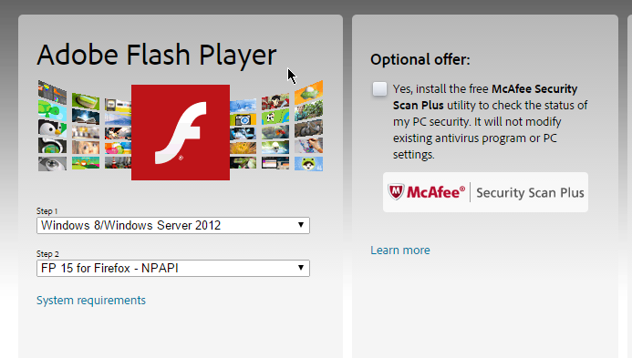

The Qt webkit can only load the NPAPI style flash plugins so the one used by Chrome and IE will not work. Select your version of Windows and the NPAPI plugin version.

Install plugin

First add the DMS qgis repository to the QGIS plugin repository list:

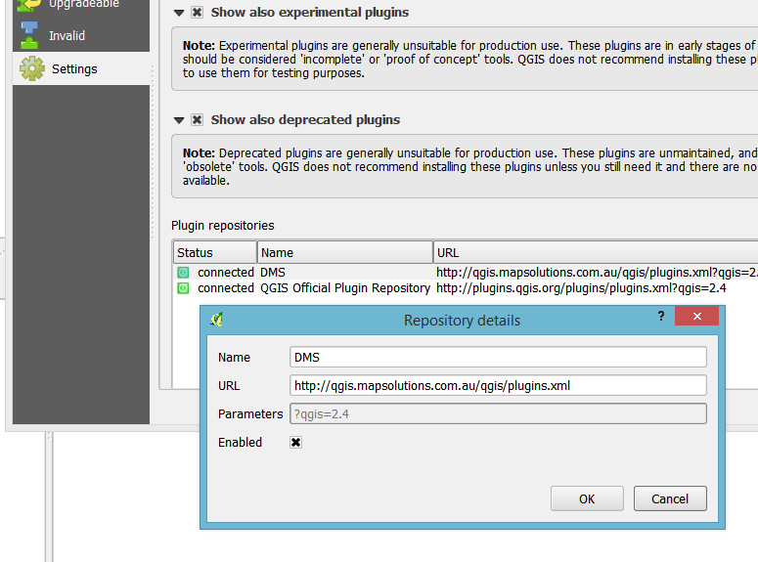

Search for “Earthmine” in the plugin list to install the plugin

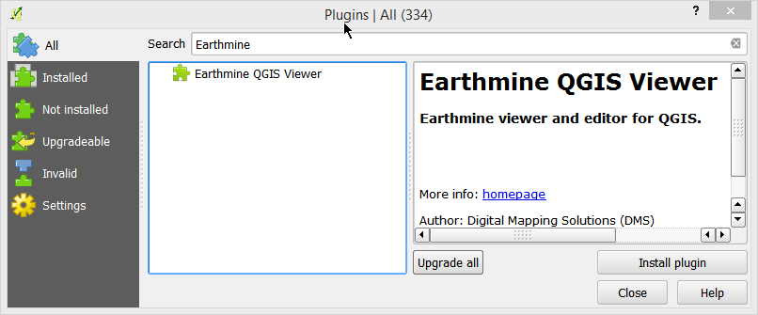

Use the settings icon on the toolbar   


Add the required settings

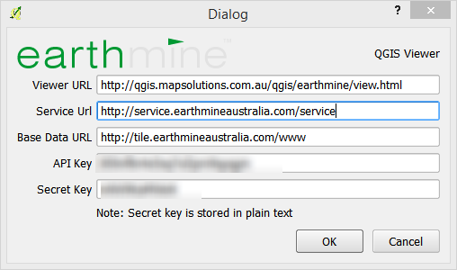

**Note: The viewer URL should point to the server which is hosting the viewer flash file. This may or may not be the same as the above screenshot.**

Close the settings dialog

# Using the viewer

Click the viewer icon on the plugin toolbar to load the viewer.

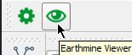

The viewer will open:

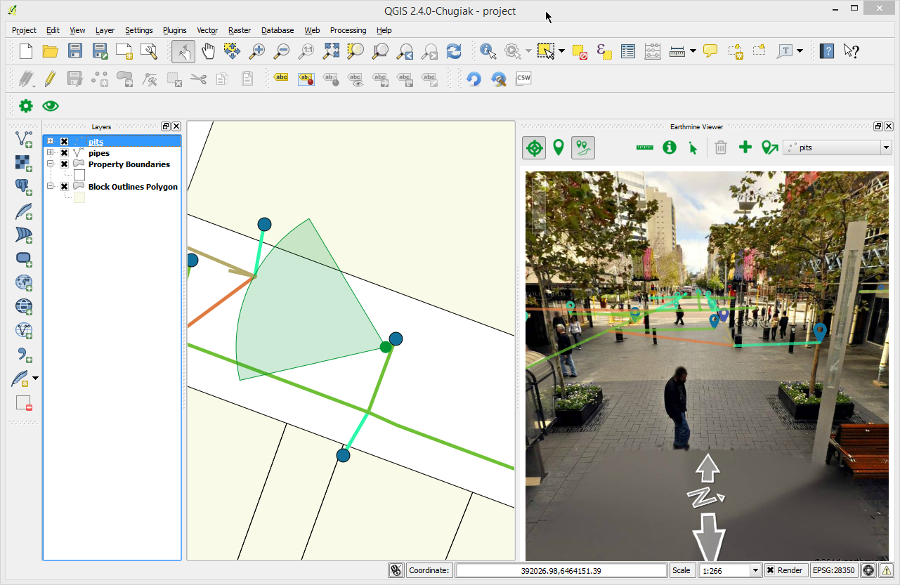

### Toolbar overview

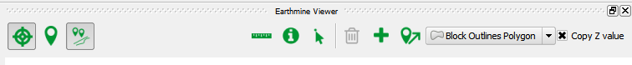

*  Track viewer location in QGIS.
*  Set location of viewer by clicking in the QGIS map
* Load visible features in viewer
*  Show measure tools
* Get info about clicked feature
*  Select feature in viewer (the same feature will be selected in QGIS)

**Edit tools.**

The following tools are only active when the selected layer is in edit mode.

*  Delete selected feature
*  Add new feature to selected layer
*  Move viewer feature under cursor
*  Active layer

### Setting Viewer Location

The viewer location is auto set the center of the map view when a new project is loaded. The location can also be set using the arrows, double clicking in the viewer, or by using the Set Location toolbar icon.

Select the  icon then click a location in the viewer.

### Measure tools

Select the measure tool from the toolbar 

The dialog with the measure options will be opened

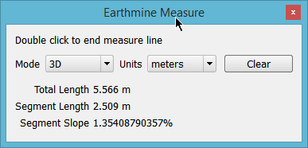

The type of measurement can be changed using the **Mode** dropdown

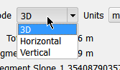

Single click in the viewer to measure between points

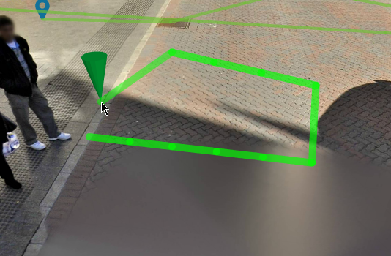

Double click to end the measure line

### Getting feature info

Select the active layer in the layer combo



Select the Info tool on the viewer toolbar



Click a feature in the viewer

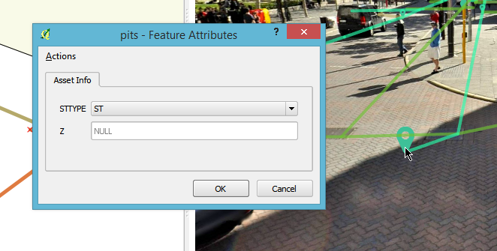

### Selecting feature

Features that are selected in QGIS and the viewer are kept in sync between both views. When using the normal QGIS select tools the same feature will be selected in the Earthmine viewer

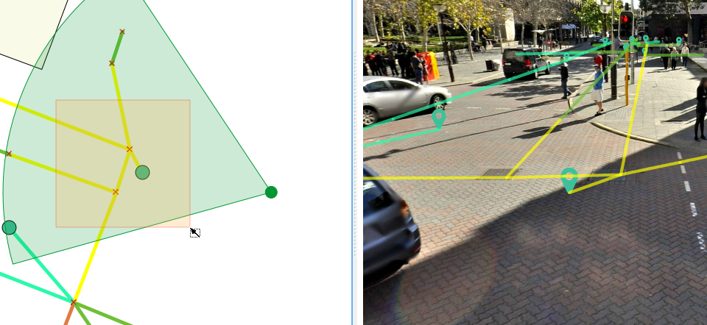

Select the Select tool  in the viewer toolbar to select a feature in the viewer and highlight it in the QGIS map

### Deleting selected features

Use the Select tools in QGIS or the viewer to select a feature then use the Delete feature  button to delete the selected feature

### Adding a new feature

New features can be added in the viewer using the Add toolbar button. New features can only be added to the selected layer which **must** be in edit mode.

Steps to add a new feature:

1. Select the active layer
2. Select the Add feature toolbar icon
3. For points
   1. Single click in the viewer to add a new feature
4. For lines
   1. Single click to a new node
   2. Double click to finish the line

**Note:** Z values will be copied to the new features (Points only) when the Copy Z Values is ticked and there is a field on the on the layer called **Z**

### Moving viewer features

Only features in the active layer can be moved.

Steps to add a move a point feature:

1. Select the point layer
2. Enabled editing for the current layer
3. Select the Move feature toolbar button
4. Click and drag a point feature in the viewer.